**2. Fuzzy Mediation and Moderated-Mediation Analysis**

**2.1 기존의 매개효과 검정 방법**

**2.1.1 Baron & Kenny**

Baron & Kenny’s (1986) research has made a clear definition of mediating effect and controlling factors and explained the logic of verification on mediating effect readily intelligibly and intuitively. It is the most widely cited method in the papers as a testing method of the mediating effect by verifying how the mediating effect can be proven.

The method has recently encountered criticisms due to a bevy of problems. When estimating the size of the mediating effect, the conclusion on the mediating effect has been made indirectly by verifying with different figures in order not by verifying from the statistical reasoning to determine if the size has a significant meaning. An error can occur at in anytime, especially when examining a hypothesis. The probability of an error is inevitably getting higher as the number of hypotheses to be proven increases simultaneously. Hence, it has turned out that the reliability of the testing is weak due to excessive errors that occurred from the sequential testing of multiple hypotheses (e.g., Fritz & MacKinnon, 2007; Hayes & Schaarkow, 2013). In addition, it is widely known that Baron & Kenny’s testing method analyzes the mediating effect based on the assumption that the effect of independent variables on the dependent variables should be statistically significant. However, it is not valid. The verification method of the mediating effect is under the criticism that it is not an accurate statistical method rather than it is not statistically close.

**2.1.2 Sobel Test**

The core problem of Baron & Kenny’s verification method occurs indirectly in the verification process of mediating effect. Sabel’s (1982) method can be considered an advanced approach in that the method calculates the magnitude of the effect directly. Researchers frequently cite the Sobel test since the method can be utilized comparatively simply than other methods in verifying the mediating effect. However, it is found that there are defects in Sobel’s verification method. When verifying the significance of the mediating effect with Sobel’s testing method, the assumption is that the sample distribution of the value forms the normal distribution. Unlike the assumption, however, the sampling distribution used widely by most researchers in mediating effect verification is mostly deflective, not showing the normal distribution (Bollen & Stein, 1990; Shrout & Bolger, 2002). Therefore, it can be deduced that Sobel’s method has limitation in telling the statistical significance of mediating effect (Fritz & MacKinnon, 2007; Hayes & Scharkow, 2013).

**2.2 Bootstrapping**

Generally, the confidence interval of the mediating effect has been calculated based on the assumption that the sampling distribution follows the normal distribution or a t distribution. However, the cases where the extracted samples do not follow a normal or t distribution are found. If the confidence interval is calculated with a normal distribution or a t distribution when the sampling distributions are not symmetrical, it can provide an approximation of the correct confidence interval. However, it cannot always provide a reliable approximate value as always. As an alternative to the weakness of the method, the bootstrapping method has recently become pervasive for researchers.

The bootstrapping method is a statistical method that estimates the sample distribution based on the empirical distribution utilizing sample data while the sample distribution is not informed. Namely, given the fact that the method can calculate the approximate standard error, confidence interval, and significance probability of the estimated sample distribution by repeatedly projecting after extracting and restoring the same-sized sample randomly without making any assumptions on the distribution of variables or sample distribution (Figure 0)

Two methods have been suggested for verifying the mediating effect with bootstrapping. First, one is to determine whether zero is included in the confidence interval of the re-extracted sample distribution, and the second is to identify the effect with the significant probability of total indirect effect through the decomposition of testing mediating method. The specific methods that calculate the confidence interval can be categorized into Percentile and Bias-corrected.

The method to examine the mediating effect by utilizing the bootstrapping method has been introduced by several scholars since the 1990s (Bolen & Stein, 1990). Despite the strengths the method has, the reason why the bootstrapping method has not been widely accepted was derived from the difficulty in executing a considerable amount of calculation without using a computer, and there were inevitable limitations in application due to its complexity in programming. However, along with the significant advancement in computer development and the simplified procedures in using bootstrapping through the various statistic packages, the utilization ratio of the method is getting higher in different academic fields. Therefore, in this paper, the statistical significance of the fuzzy mediation model was explained using bootstrap.

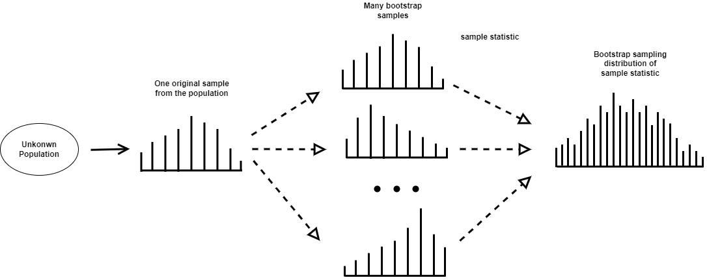

**2.2.1 Percentile bootstrap**

When the magnitude of the influence of the independent variable on the parameter is set as a, and the magnitude of the effect of the parameter on the dependent variable, controlling the influence of the independent variable, is set as b, the indirect effect can be defined as ab. Among the reasoning methods that do not require assumptions on the sampling distribution of ab that refers to the magnitude of the indirect effect, there is a typical method that test the indirect effect by utilizing the confidence interval of a bootstrap. One of the procedures to set the confidence interval (95%) by the percentile bootstrap method is as follows (Shrout & Bolger 2002). All procedures are automatically carried out in PROCESS macro, a computer program developed by Hayes.

Reinforcement is extracted from the original sample with sample size N extracted from the population, and a bootstrap sample with the same size N as the original sample is extracted.

1. Using the bootstrap sample obtained in step 1, estimate the statistics of indirect effects in the resampling.
2. Repeat steps 1 and 2 k times to generate k bootstrap samples and estimate and store k indirect effects using them.
3. Sort the k indirect effect estimates from lowest to highest.
4. In the case of using a 95% confidence interval, the lower limit is defined as the statistic value corresponding to the 0.5th (100-95)th percentile of the distribution of the previously obtained statistic value. The upper bound is defined as the statistic corresponding to the [100-0.5 (100-95)]th percentile from the distribution of k statistics arranged in ascending order. The lower and upper bound values are determined as the endpoints of the 95% confidence interval.

If 0 is not included in this 95% confidence interval, the indirect effect is said to be statistically significant.

**2.2.2 Bias-corrected bootstrap**

A bias-corrected bootstrap compliments the potential bias in percentile bootstrap confidence intervals was suggested by Efron and Tibshirani (1986). The Bias-corrected approach shares the same grounds with the percentile confidence interval. However, it is different from the percentile bootstrap confidence interval in that the bias constant is calculated by utilizing the ratio of the point numbers more minor than the point estimate value of the indirect effect of the original sample among the k indirect effect estimates calculated from the k bootstrap samples. It is a revised confidence interval that equals the error rates of both ends of the percentile bootstrap confidence interval. It determines the upper and lower bounds of the confidence interval by closely reflecting the asymmetry of the bootstrap estimate distribution. Therefore, when the sampling distribution of the estimate is not symmetrical, the Bias-corrected method is more suitable for obtaining more accurate results. However, recently, several reports have mentioned that bias-corrected bootstrapping may not be a proper testing method since it causes type I error despite its high proving capability (Biesanz et al.,2010, Hayes & Scharkow, 2013, Falk & Biesanz, 2015, Tofighi & Kelly, 2020).

**3. Fuzzy Mediation and Moderated-Mediation Analysis**

In this section, we introduce the definition of fuzzy numbers by Zadeh [] and simple fuzzy mediation models with mediators introduced by Yoon [].

**3.1 Fuzzy number**

퍼지 숫자는 실수 R에서 정의되는 퍼지 집합으로서 정규화되고 볼록할 때를 의미한다. 퍼지집합은 Membership function이라고 불리는 함수에 의해 0과 1사이의 실수 값을 소속척도로 취하는 원소들로 구성된다. Membership function의 형태는 객관적이거나 주관적인 가능성을 고려하여 정의할 수 있어 일반적인 규칙이 존재하지 않는다. 따라서 특정한 경우로 LR-퍼지 숫자라고 하는 퍼지 숫자의 parametric class가 사용된다. 퍼지 숫자A가 다음과 같은 조건을 만족하면 LR 퍼지숫자라 한다.

$$μ_{A}\left(x\right)= \left\{\begin{aligned}L\left(\frac{m-x}{l}\right) if x≤m, \\ R\left(\frac{x-m}{r}\right) if x>m,\end{aligned}\right.$$

where L and R are reference functions called left and right shape functions of X and have the following properties : L,R :R→[0,1] are left-continuous and decreasing function with R(0) = L(0) = 1, R(1) = L(1) = 0. And ‘m’ means the mode of the LR-fuzzy number A. ‘l’ and ‘r’ are greater than 0 and mean the width of the left and right sides. We abbreviate the LR-fuzzy number as $A = {(m, l, r)}_{LR}$.

**3.2 Fuzzy Simple Mediation Model**

변수가 모호할 경우 crisp 숫자보단 퍼지 숫자를 사용하여 표현하는 것이 더 합리적이다. Fuzzy Mediation Model은 다음과 같이 제안된다.

**3.3 Fuzzy Mediation Model for Multiple Mediation**

**3.4 Fuzzy Moderated-Mediation Model**

**4. Bootstrapping for Fuzzy Mediation and Moderated-Mediation Analysis**

**4.1 Statistical Inferences of Fuzzy Mediation**

**4.1.1 Inferences on the total, direct and Indirect Effect**

**4.2 Statistical Inferences of Fuzzy Moderated-Mediation**

**4.2.1 Inferences on the total, direct and Indirect Effect**